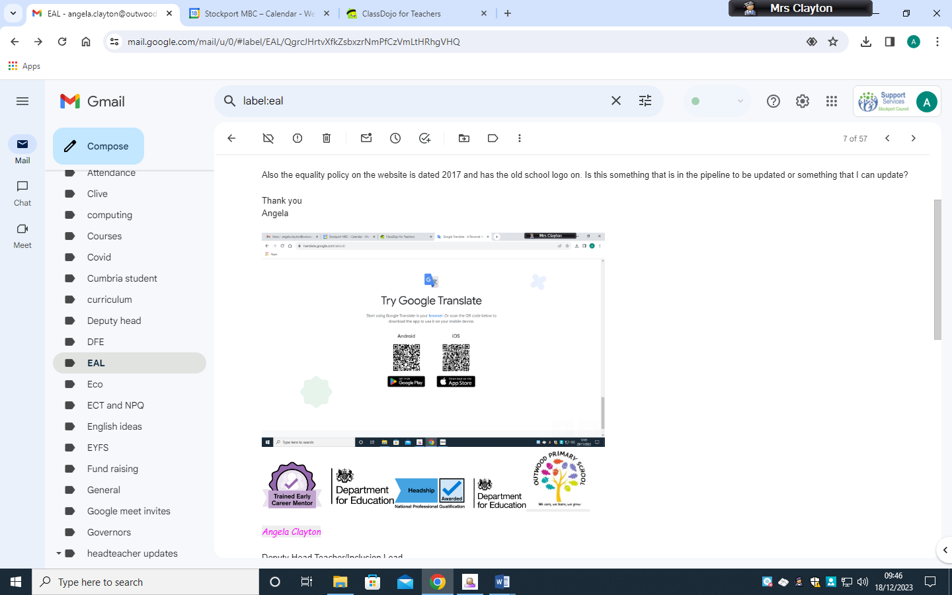 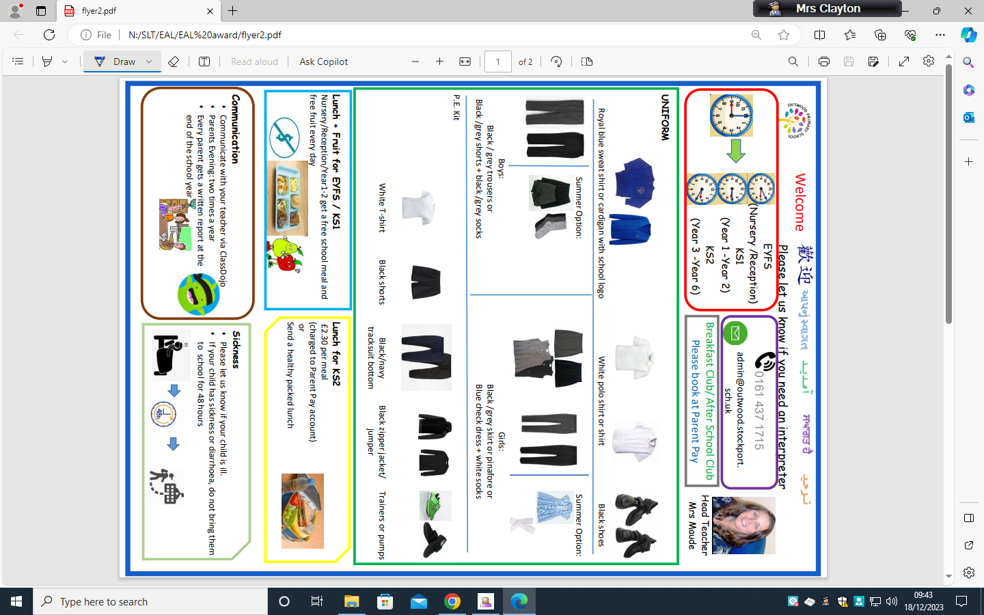

**Google Translate**: We want everyone to be able to access our communications so please find opposite google translate for all families to access.